**GROUPME Chat**

**Project Conversation over the course of the semester**

**JAN 26, 9:20 AM**



**Nick Yarbrough**

Test

**JAN 26, 10:30 AM**



**Shervon**

Mine's good

**JAN 26, 10:40 AM**

**Private Tarver**

Same

**JAN 28, 8:11 AM**



**Shervon**

I'm running late guys

Will be there in 15 mins

**FEB 1, 8:53 PM**



**Nick Yarbrough**

Do we need to do anything?

**FEB 1, 10:06 PM**



**Private Tarver**

Nope just the assignment thats due the 4th

**FEB 4, 7:46 AM**



**Nick Yarbrough**

Running a little late. I'll be there at 815. Unless yall are skipping



**Private Tarver**

I'll be there just running larec also

Late\*

**FEB 4, 8:51 AM**



**Nick Yarbrough**

Alright gents we are booked and bueno!

You need anything else from me?



**Shervon**

Perfect

We're good for now



**Nick Yarbrough**

Excellent. See yall at 5!

**FEB 4, 4:49 PM**



**Shervon**

Can you guys start without me. I will be about 15 mins late. I need to sit in on a meeting for a few mins

**FEB 4, 5:09 PM**



**Nick Yarbrough**

All good. Walking in the door

Phones dead but I'll be in the tech center in the union.

**FEB 4, 5:29 PM**



**Private Tarver**

Where are yall?

**FEB 4, 5:30 PM**



**Nick Yarbrough**

in the room

lol where are you?

are you in the union



**Private Tarver**

Yep



**Shervon**

We're on the same floor as the dining hall



**Private Tarver**

In the that lab?



**Nick Yarbrough**

sortq

the tech centwr right in front of the dining ha'l

**FEB 11, 9:24 AM**



**Nick Yarbrough**

We only had a speaker in class today correct?

**FEB 11, 4:29 PM**



**Shervon**

Yep

**FEB 15, 1:26 PM**



**Nick Yarbrough**

I'll be there tomorrow, no worries

**FEB 16, 12:56 PM**



**Private Tarver**

Did i miss anything today?

**FEB 16, 1:05 PM**



**Nick Yarbrough**

No, we started the VP project

**FEB 16, 2:58 PM**



**Private Tarver**

Alright

**FEB 16, 3:24 PM**



**Shervon**

I haven't seen an email from him yet

I completely forgot haha

**FEB 18, 8:57 AM**



**Shervon**

Are you guys in class today?



**Nick Yarbrough**

No



**Private Tarver**

Nope haha



**Shervon**

Lol

**FEB 18, 8:59 AM**



**Shervon**

We're all a bunch of jokers lol

**FEB 18, 9:10 AM**



**Nick Yarbrough**

Meh, we can do everything from home at anytime instead of being in class this early

**FEB 28, 4:20 PM**



**Private Tarver**

How'd y'all do the enroll table relation?



**Nick Yarbrough**

What do you mean?



**Private Tarver**

As in primary/ foreign key



**Nick Yarbrough**

Student is my primary and class is my secondary

**FEB 28, 8:00 PM**



**Private Tarver**

Hmm on the enroll posnum did y'all put some sort of auto increment?

**FEB 28, 8:10 PM**



**Nick Yarbrough**

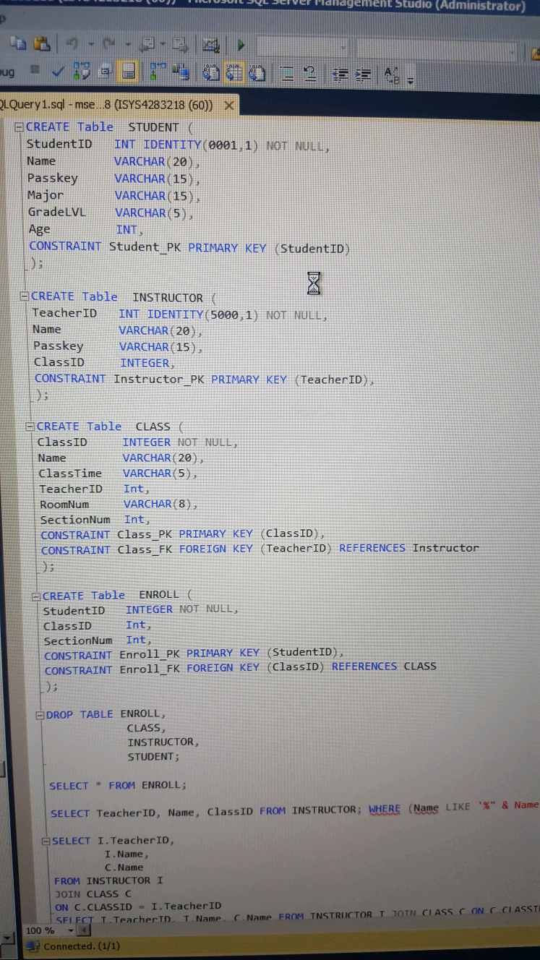

Oh....that would've been better

**FEB 28, 8:17 PM**



**Private Tarver**

Alright I'm just over thinking this



**Nick Yarbrough**

No no that is a good idea though!



**Private Tarver**

I've tried it. I can't get it to increment like in his example queries



**Nick Yarbrough**

What program are you using for your database?

**FEB 28, 8:32 PM**



**Private Tarver**

Sql server



**Nick Yarbrough**

Ahh

**FEB 29, 11:24 AM**



**Shervon**

I still haven't worked on mine much yet

**FEB 29, 5:40 PM**



**Private Tarver**

Anyone get the datagrid to work?



**Nick Yarbrough**

Not yet. I'm still working on it



**Shervon**

I'm at the STEM career event

Will be working on it tomorrow

**FEB 29, 5:43 PM**



**Private Tarver**

It's b.s. I can load a data grid.

The part I can't get is changing the view based on the combobox item selected....

**FEB 29, 6:00 PM**



**Nick Yarbrough**

Are you using on click?

**FEB 29, 6:54 PM**



**Private Tarver**

The event would be selectedindexchange



**Nick Yarbrough**

Wouldn't that just return the index number?



**Private Tarver**

I gave up

Yeah



**Nick Yarbrough**

Is it due in class tomorrow? Or tomorrow night?



**Private Tarver**

Not due till the 3rd



**Nick Yarbrough**

WHAAAAAAT!



**Private Tarver**

At midnight



**Nick Yarbrough**

I've been cramming the shit out of this -\_-



**Private Tarver**

Yep :/



**Nick Yarbrough**

Do you wanna see my code?

Try using SelectedText



**Private Tarver**

I'm sapped already are you going to class tomorrow?

I'll look off it then if you are



**Nick Yarbrough**

Yeah, I'll be there

We can work on it then



**Private Tarver**

Sweet 

**MAR 1, 7:52 AM**



**Shervon**

I won't be at class today

**MAR 1, 8:18 AM**



**Private Tarver**

Alright

Nick you coming?

**MAR 1, 8:31 AM**



**Nick Yarbrough**

Sorry, I woke up late. I'm walking down the hill to JBHT now

**MAR 2, 5:29 PM**



**Private Tarver**

Hey question. I'm having trouble pulling integers into the textboxes

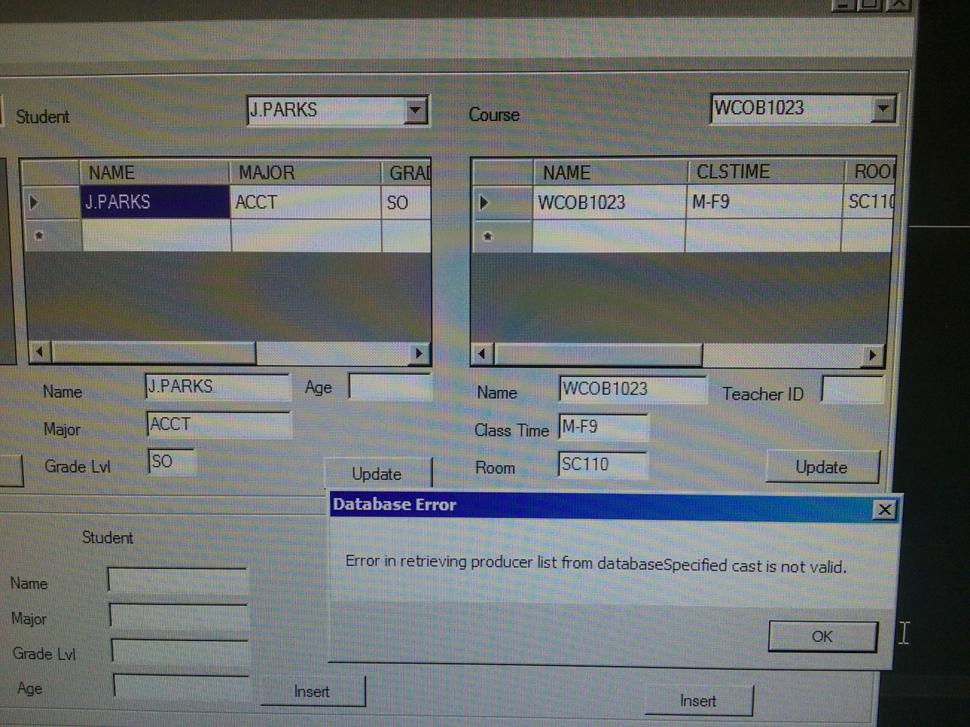



**Nick Yarbrough**

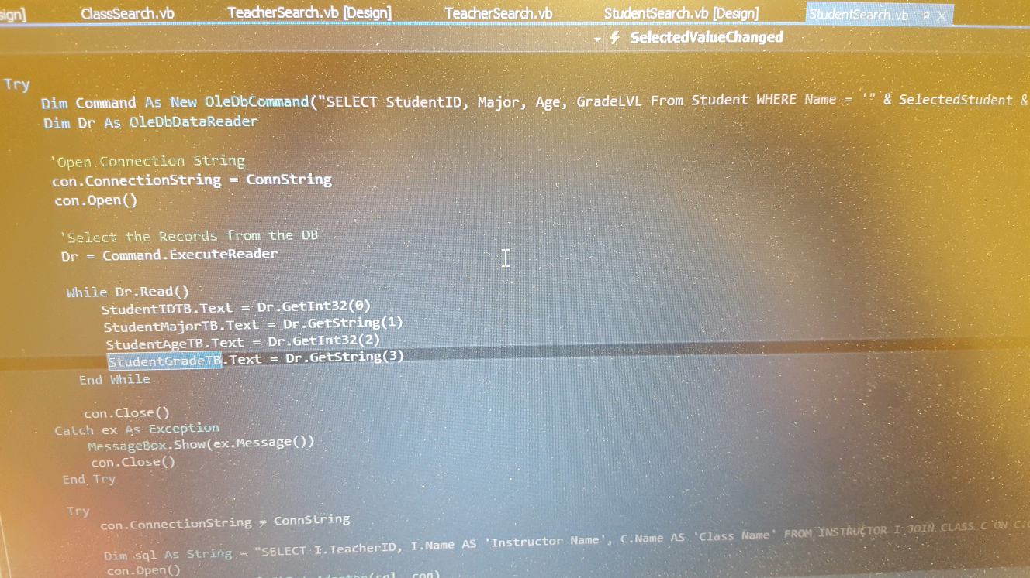

Let me know if you don't see the discrepancy



**Private Tarver**

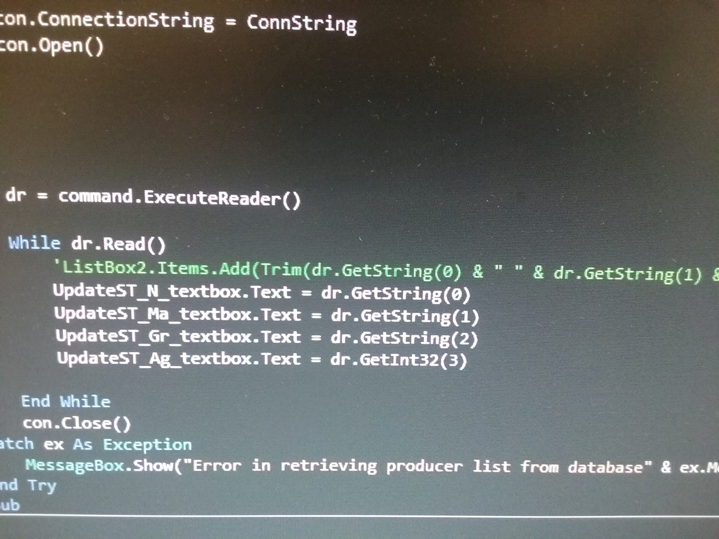

I've already got that :/



**Nick Yarbrough**

Is grade a string or int?

How many variables are you trying to pull in and how many are you trying to display?



**Private Tarver**

It's a string in my database



**Nick Yarbrough**

Kk

Hmmm, I may have to look at it tomorrow



**Private Tarver**

Bringing in four and displaying four



**Nick Yarbrough**

:&



**Private Tarver**

Well dang I'll show ya tomorrow

**MAR 3, 7:20 AM**



**Nick Yarbrough**

**@Private Tarver** are you going to class today?



**Private Tarver**

Yeah I'll be there between 8-8:15

Till 9:15

**MAR 3, 5:15 PM**



**Private Tarver**

Mind if I take a look at your code nick?



**Shervon**

I think I would like to as well

**MAR 3, 6:20 PM**



**Nick Yarbrough**

Sure. I can send you two programs

**MAR 3, 6:37 PM**



**Private Tarver**

Sweet only thing I'm missing are those next, previous buttons and the class enrollment search

I'm on campus working on it shervon. If you're nearby



**Shervon**

I just got home

Were you able to change your combo box ?



**Private Tarver**

You mean for casting error?



**Shervon**

Yeah that as well



**Private Tarver**

The casting error I fixed by changing getstring to getint16



**Shervon**

Are you on campus for some time?



**Private Tarver**

Yeah probably till midnight haha



**Shervon**

Haha well I will go back to the school

Where are you now?



**Private Tarver**

In the Walton computer lab

**MAR 3, 9:09 PM**



**Nick Yarbrough**

[vbnet assignment 1.zip](https://www.dropbox.com/s/detx4ee631m6oql/vbnet%20assignment%201.zip?dl=0" \t "_blank)

[dropbox.com](https://www.dropbox.com/s/detx4ee631m6oql/vbnet%20assignment%201.zip?dl=0" \t "_blank)

**MAR 31, 7:49 AM**



**Shervon**

I'm not coming to class this morning guys. Tarver if you want to we can meet up sometime on the weekend to finish up the GANTT Chart that Nick started. It's due on Tuesday

**MAR 31, 1:21 PM**



**Nick Yarbrough**

I'll try to get my 3 documents done today

**MAR 31, 5:10 PM**



**Private Tarver**

Alright thats fine



**Nick Yarbrough**

If I need to work on anything while I'm away, holler at me and I'll TRY to get to it, but no promises

**APR 2, 12:12 PM**



**Private Tarver**

When did did you you want to work on on the project shervon?

**APR 2, 1:48 PM**



**Shervon**

Hey man when are you free? I was thinking maybe tomorrow

**APR 2, 4:54 PM**



**Private Tarver**

Tomorrow is fine

**APR 3, 10:45 AM**



**Shervon**

How about 4



**Private Tarver**

alrighty

**APR 3, 3:07 PM**



**Private Tarver**

Whered you want to meet?

**APR 3, 3:26 PM**



**Shervon**

In the WCOB lab

**APR 3, 4:17 PM**



**Shervon**

Are you at the right lab?



**Private Tarver**

Im here now



**Shervon**

I'm there as well lol

Are you at the Walton college or at the Union?



**Private Tarver**

Walton

**APR 3, 4:55 PM**



**Private Tarver**

**@Nick Yarbrough**   
Hey have you completed those 3 documents?

**APR 3, 5:11 PM**



**Private Tarver**

We will need them done by this friday



**Nick Yarbrough**

I have not. It's unlikely I will have time, but I will try to take a look at them

**APR 5, 8:04 AM**



**Private Tarver**

You coming? **@Shervon**

**APR 5, 3:55 PM**



**Shervon**

Are you still at the school?



**Private Tarver**

Yeah whats up?



**Shervon**

I wanted to take a look at your code for Mackey's in class assignment. Are you busy now



**Private Tarver**

Yeah ill be done with class at 4:45

**APR 5, 4:00 PM**



**Private Tarver**

I can send you the files though....



**Shervon**

Ok I'm free till 6 so I'm trying to get it done

**APR 5, 4:09 PM**



**Private Tarver**

Alright just uploaded to that shared folder

On google drive



**Shervon**

Ok thanks man!

**APR 5, 5:17 PM**



**Shervon**

Mine is almost the same as yours so I'm not sure why it doesn't work

Are you on campus still?

**APR 5, 5:33 PM**



**Private Tarver**

not anymore :/

Is the compilation part working?

**APR 5, 5:50 PM**



**Shervon**

I believe so

Can you send my yours



**Private Tarver**

I did its inside that folder



**Shervon**

How many files did you put in there?



**Private Tarver**

2



**Shervon**

Ok I only checked out 1



**Private Tarver**

One should be the compiler and the other is the cobol



**Shervon**

I'll take a look at the other later

Yeah I'm not sure why mine isn't working

Both of my files should be okay

**APR 5, 6:10 PM**



**Private Tarver**

Hmm not sure

**APR 5, 6:10 PM**



**Private Tarver**

What error are you getting?

**APR 6, 6:09 PM**



**Shervon**

Dude I'm just watching this message

He's talking about the project tonight lol



**Private Tarver**

What!?

**APR 6, 6:45 PM**



**Shervon**

Lol there will be a project lol

**APR 8, 3:55 PM**



**Shervon**

I think I lost the message you sent earlier

Do you still want to meet up today

**APR 8, 4:02 PM**



**Private Tarver**

I asked earlier what portion of nicks are you taking?



**Shervon**

I can take the first two

**APR 8, 4:18 PM**



**Private Tarver**

Alrighty

**APR 8, 4:52 PM**



**Shervon**

I guess we don't need to meet up to work on it. We can meet up on Sunday

**APR 8, 5:19 PM**



**Private Tarver**

Yeah that's fine

**APR 9, 5:08 PM**



**Private Tarver**

**@Nick Yarbrough**   
If you don't already have a git hub account could you go ahead and sign up for one?

We are using it as our project collaboration utility

Let me know what email you used and I'll add you to the group

**APR 9, 5:17 PM**



**Private Tarver**

**@Shervon**   
Do you have an example from previous projects on the "proposal"?

**APR 9, 5:30 PM**



**Shervon**

I will search through my files to see. I didn't save all the files from my previous group so I may not have it

**APR 9, 6:36 PM**



**Nick Yarbrough**

[Nnyarbro@gmail.com](mailto:Nnyarbro@gmail.com) will be the email

**APR 10, 1:24 PM**



**Private Tarver**

Were we still meeting? **@Shervon**

**APR 10, 1:40 PM**



**Shervon**

I'm working on my section right now so I guess we don't have to if you can't make it

**APR 12, 7:25 AM**



**Shervon**

Dude I can't make it to class today! I'm studying for an exam this afternoon

**APR 12, 1:35 PM**



**Private Tarver**

Ha it was fine. Each group talked with the mentor on an individual level

**@Nick Yarbrough**   
Did you ever sign up for github? It's saying that email address is invalid

**APR 12, 1:57 PM**



**Shervon**

Who was the mentor?

**APR 12, 2:20 PM**



**Private Tarver**

Can't remember his name it was kinda strange

He didn't even say who he worked for

Hes just a project manager that's been in multiple industries

**APR 12, 2:32 PM**



**Shervon**

Was it Ben?



**Private Tarver**

Nope

Name was something like "munae"

**APR 12, 3:43 PM**



**Shervon**

Ok

**APR 12, 8:04 PM**



**Nick Yarbrough**

**@Private Tarver** username or email

Email is [nnyarbro@gmail.com](mailto:nnyarbro@gmail.com)

Username is NickYarbrough

**APR 17, 9:19 PM**



**Nick Yarbrough**

Please let me know what i need to start working on

**APR 18, 11:02 AM**



**Private Tarver**

**1**

We've decided to just start on the programming. We've done phase 1. We figured documentation and the like would be easier to deal with towards the end versus the beginning

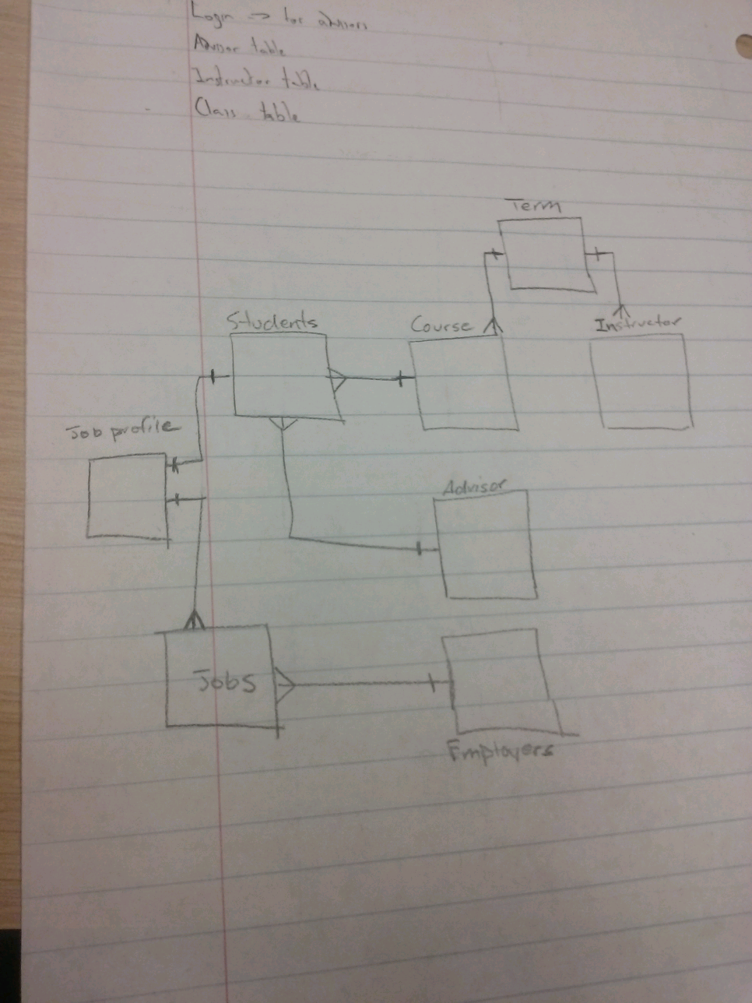

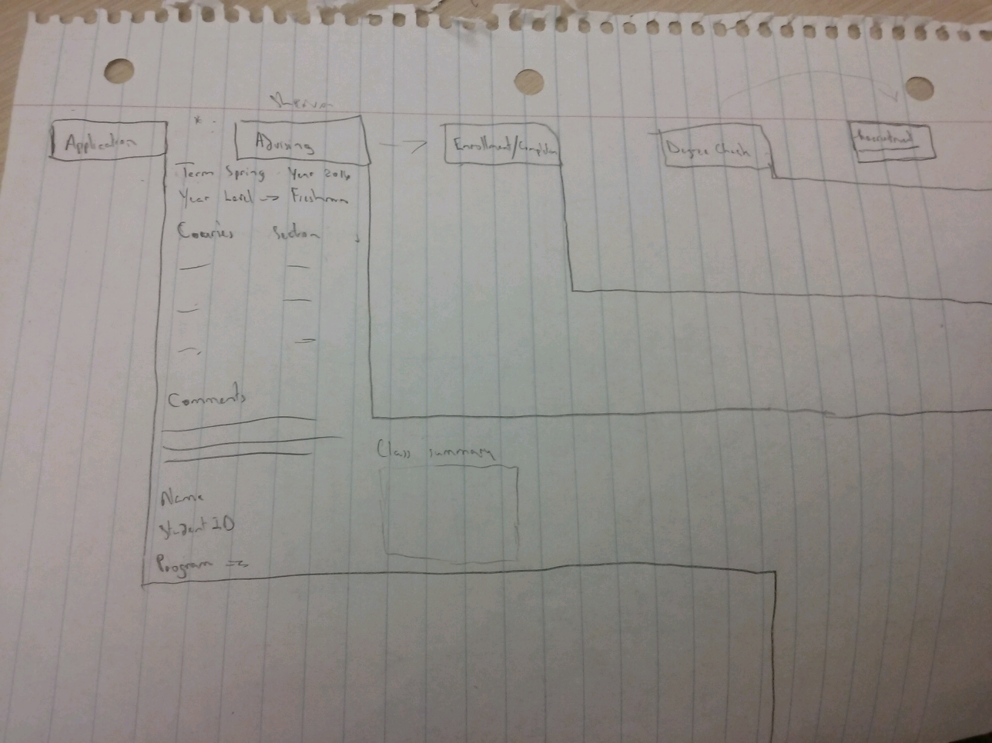

I'm working on the initial application screen and shervon has the advising and the enrollment

We figured you'd give you the graduation check and recruitment

**APR 18, 11:09 AM**



**Private Tarver**

We'd

**1**

I can explain more In class tomorrow

Also you should of been added to our git hub repository



**Nick Yarbrough**

Excellent

**APR 19, 4:42 PM**



**Private Tarver**

Alright the publish feature on the visual studio: github extension was finally found!

Once extension is set up click—> team explorer---->changes---->write in comment—>select commit and push

**APR 19, 4:48 PM**



**Nick Yarbrough**

Awesome! Please set up a basic visual studio build and ill start on ass.5

**APR 19, 5:14 PM**



**Private Tarver**

It's already been uploaded

**APR 19, 8:34 PM**



**Nick Yarbrough**

My man!

**APR 20, 8:15 PM**



**Private Tarver**

I'll be working on this all day Saturday on campus.. If y'all want to meet up

Also all day friday

**APR 20, 9:07 PM**



**Shervon**

Ok no problem. I have an event at the school on Saturday day till about two so I will join you after

I can work on it after work tomorrow

**APR 20, 9:58 PM**



**Nick Yarbrough**

Next week will probably be when i work on it

**APR 20, 10:39 PM**



**Nick Yarbrough**

Probably gonna be a hair late to class, unless yall arent going.

**APR 21, 7:35 AM**



**Private Tarver**

Yeah won't be there

**APR 21, 7:56 AM**



**Nick Yarbrough**

Im working from home as well

**APR 21, 8:57 AM**



**Shervon**

I guess me either lol. I left the school late last night and woke up late



**Nick Yarbrough**

Lolol

**APR 22, 8:44 PM**



**Private Tarver**

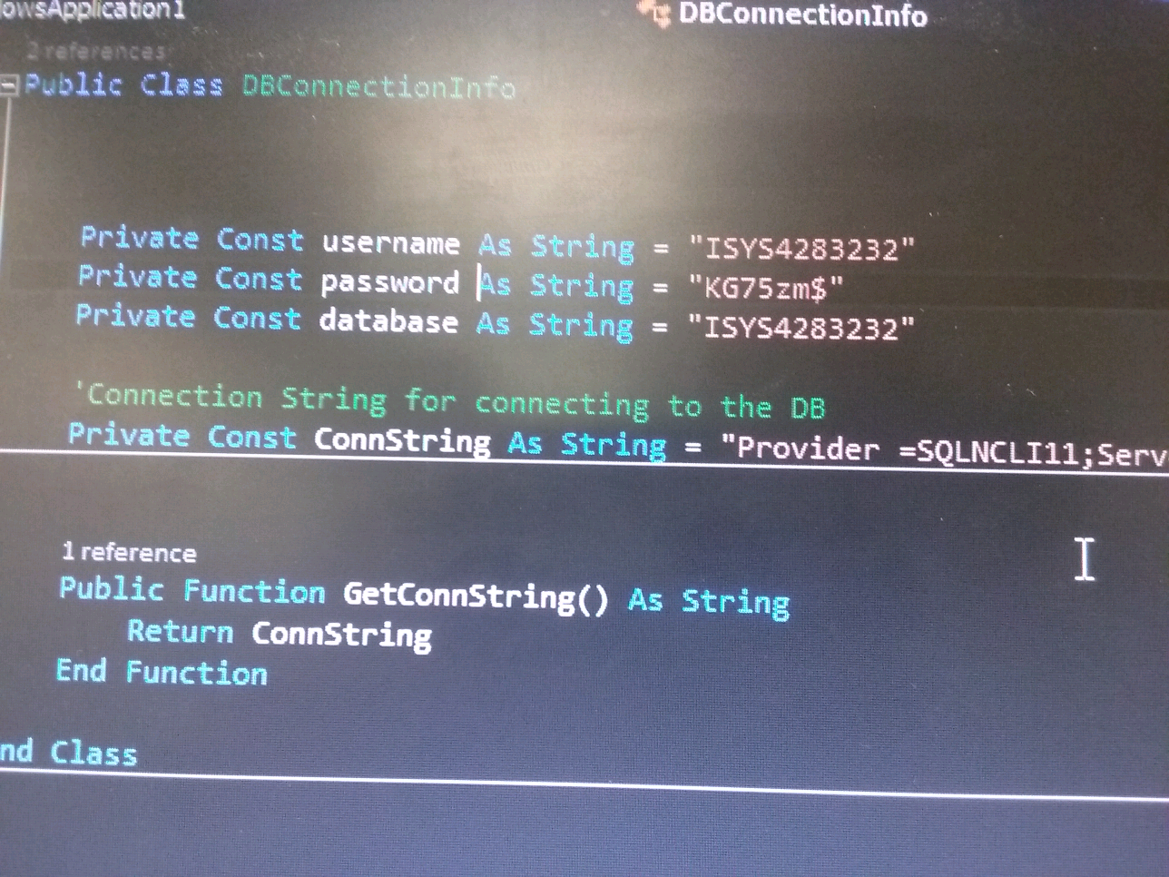

**APR 22, 8:45 PM**



**Private Tarver**

Hey create your tables if you can inside my database



**Nick Yarbrough**

Nice!

;) talk dirty to me



**Private Tarver**

Mmmmmm

;)



**Nick Yarbrough**

Idk that we can creat tables in your database

Wait

Nvm, we can log into MiSQL and do it



**Private Tarver**

Yeah shervon just tried it





**Shervon**

Yeah you can

Use sql server

2012

**APR 23, 10:10 AM**



**Private Tarver**

We will meeting in the Walton lab **@Nick Yarbrough**

In the next 1 or 2 hrs if you want to join



**Nick Yarbrough**

Im working a 12 today and an 8 tomorrow :/ sorry



**Private Tarver**

Oh dang haha it's fine

Oh dang haha it's fine

**APR 23, 11:43 AM**



**Shervon**

I'm on my way

**APR 25, 10:32 PM**



**Nick Yarbrough**

Ill be in a lab tomorrow at 830

**APR 28, 7:15 AM**



**Private Tarver**

You going to class? **@Nick Yarbrough**

**APR 28, 7:30 AM**



**Nick Yarbrough**

If yall are i will. We could also just chill in a lab. What do tall think?



**Private Tarver**

I'll be there or if you have some time free to meet later today



**Nick Yarbrough**

Il be there abt 820



**Private Tarver**

Alright

**APR 28, 8:11 AM**



**Shervon**

I can't make it today again but I'll be working on it on the weekend

**APR 30, 11:45 AM**



**Private Tarver**

I'm at the school doing the project if y'all are available

**APR 30, 12:53 PM**



**Nick Yarbrough**

I will be working on mine starting monday

**APR 30, 3:38 PM**



**Private Tarver**

Alright

I uploaded my newest version

Everything besides the update function and a couple other minor fixes.

Update function executes fine in the program but not updating the db for some reason

But anyway if y'all want to look at it



**Nick Yarbrough**

Thanks bud

**MON, 12:54 PM**



**Private Tarver**

So when are yall free today?

**MON, 2:08 PM**



**Private Tarver**

I'll be free after 7

**MON, 2:22 PM**



**Nick Yarbrough**

Same

**MON, 3:44 PM**



**Shervon**

Ok we can meet around 7 then

**MON, 6:46 PM**



**Nick Yarbrough**

Sorry guys!

I wont be available for about an hr. Gotta hit the gym -\_-

**MON, 6:47 PM**



**Nick Yarbrough**

If yall wanna delay till 8 and meet at the starbucks on mlk ill buy your coffee

Otherwise ill head to campus about 730

**MON, 6:54 PM**



**Nick Yarbrough**

Just let me know

**MON, 7:10 PM**



**Private Tarver**

We can just meet up in the Walton lab.

We can wait on ya



**Nick Yarbrough**

Kk, leaving the gym now



**Shervon**

I went home so heading back to the school in a minute



**Nick Yarbrough**

Gonna grab a change of clothes then head that way

**MON, 7:28 PM**



**Nick Yarbrough**

Where yall at?



**Private Tarver**

I'm in the Walton downstairs meeting room



**Nick Yarbrough**

O.o? You got a room number?



**Shervon**

I'm at chick fill a

Coming n a second



**Private Tarver**

No just still with another group



**Nick Yarbrough**

Ooh! Wanna meet in yhe lab across from our class room?



**Private Tarver**

That's fine

**TUE, 4:18 AM**



**Private Tarver**

Won't be in class today. I've got a presentation to prepare for on another project.

**TUE, 7:48 AM**



**Nick Yarbrough**

Same. Working on mine frome home

**WED, 11:05 AM**



**Nick Yarbrough**

Was anyone able to combine all our parts into one?

One file that is

**WED, 11:19 AM**



**Shervon**

We haven't tried yet

I'll get mine in by this afternoon



**Nick Yarbrough**

Kk

Ill just continue to build from mine

**WED, 12:29 PM**



**Nick Yarbrough**

**@Shervon** do you have a graduation check? Or a field that tells their year as senior or '4'

**WED, 12:40 PM**



**Shervon**

I will have to check give me a few mins



**Nick Yarbrough**

Take your time. No rush. I have other stuff to work on. I may need help getting a few things finished on here if either of yall finish your parts

**WED, 1:52 PM**



**Private Tarver**

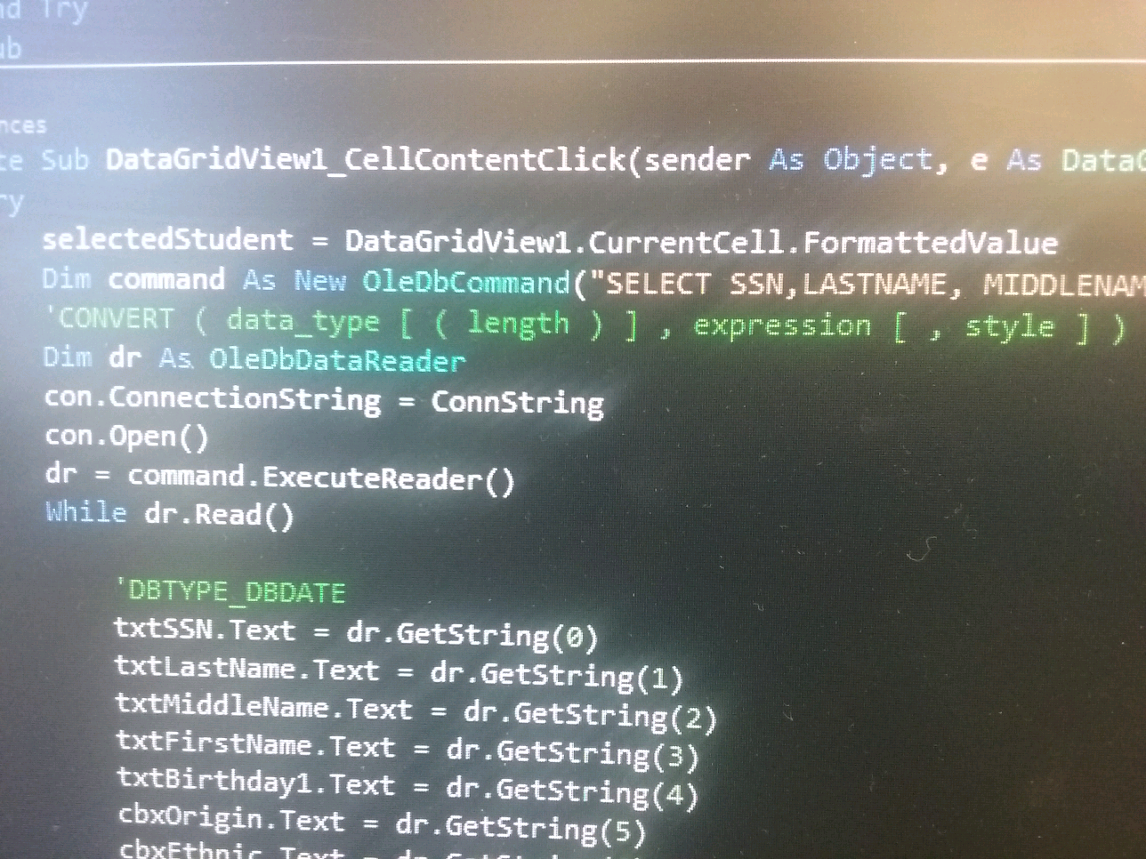

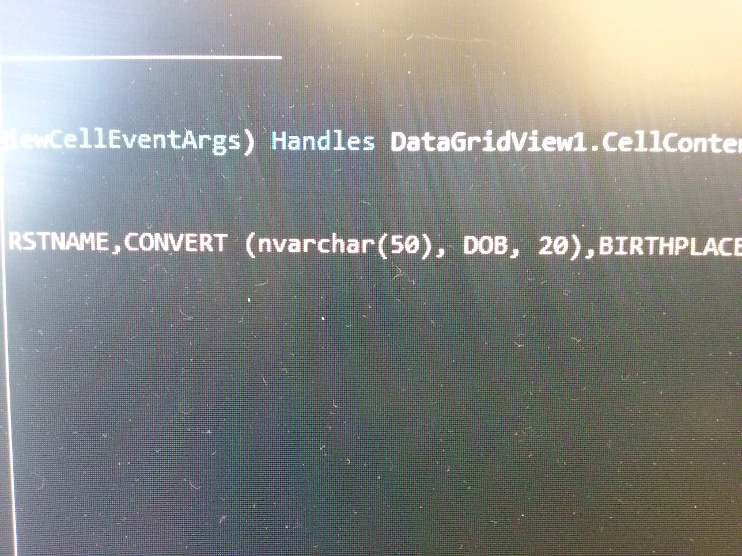

If y'all need to display dates from the table use this in the select statement

And dr.???? Would just be a regular dr.getstring (0)

**WED, 2:11 PM**



**Private Tarver**

This\*

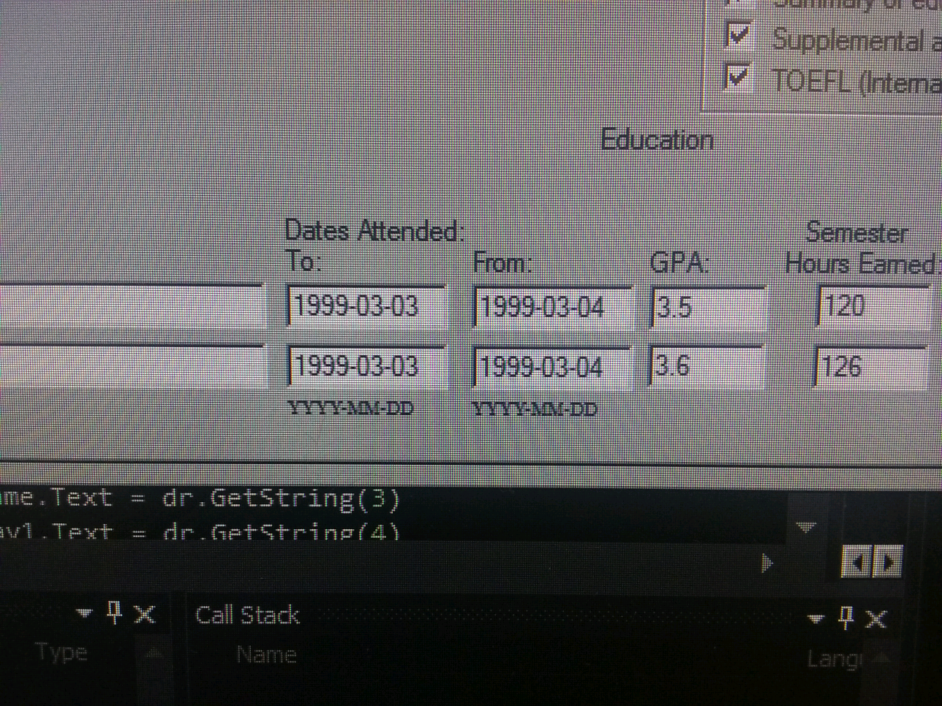

Should pull it in like tgis

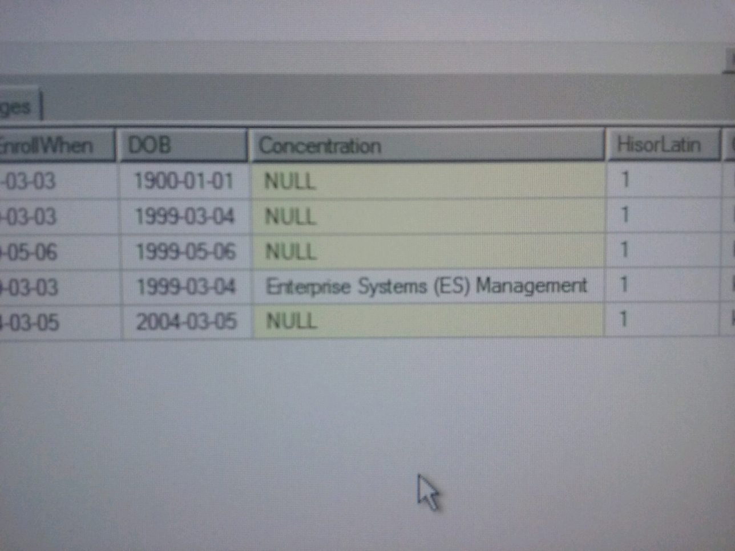

**@Shervon** the concentration field is there if you need it



**Nick Yarbrough**

Is MIS the only major available?



**Private Tarver**

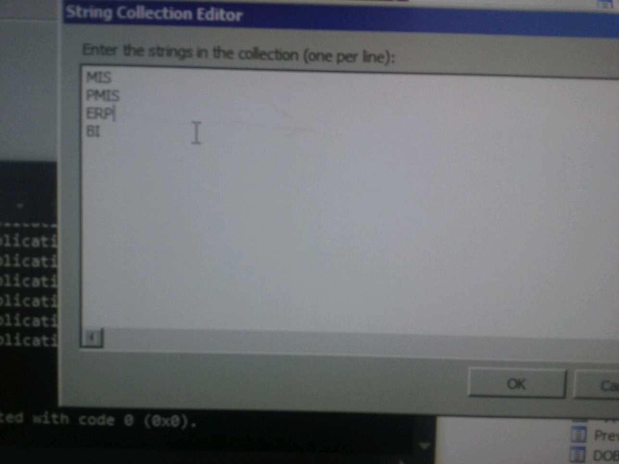



**Nick Yarbrough**

What field is that stored in in your DB



**Private Tarver**

Admitreqprogram

Yeah terrible naming haha



**Nick Yarbrough**

.....thats a really long word for Major......

**WED, 2:20 PM**



**Private Tarver**

Alright its now "major"

**WED, 2:27 PM**



**Nick Yarbrough**

Hahahahahahaha

**WED, 2:48 PM**



**Shervon**

I'm working on mine as well and man!



**Private Tarver**

Sweet!

**WED, 2:53 PM**



**Private Tarver**

Update statement works now

Everything is fixed I can think of

I'll upload mine the only thing I have left is if there are "improvements" I could make to the program

**WED, 3:11 PM**



**Nick Yarbrough**

Mine's about 2/3 of the way done

**WED, 3:18 PM**



**Private Tarver**

Alright sweet let know when you're done and uploaded to github. I'll integrate my part into it

I won't be doing it till after 9 so you've got some time



**Nick Yarbrough**

I probably wont be done till thursday or friday

**WED, 3:30 PM**



**Private Tarver**

Guess we'll have to just show Jena in parts then tomorrow

Wbu? **@Shervon**



**Nick Yarbrough**

You should probably add more entries into the database

**WED, 4:44 PM**



**Private Tarver**

**1**

Yeah i will



**Nick Yarbrough**

Just uploaded what i have

Please take a look and see if there is anything you can help with.

I will keep working on it as i can

**THU, 7:44 AM**



**Private Tarver**

Running slightly late

**THU, 7:59 AM**



**Shervon**

I just got there

**THU, 4:51 PM**



**Private Tarver**

Where we meeting at?

Walton lab?



**Nick Yarbrough**

I have a test at 6. Ill be there abt7



**Private Tarver**

Alrighty

**THU, 5:02 PM**



**Shervon**

I'll be there soon

I'm meeting my advisor now



**Private Tarver**

I'm going home for a bit



**Shervon**

Ok. I wanted to show you something first

Give me about 10 mins



**Private Tarver**

I'm about halfway to my car. Can you take a pic?

I need to get to the bank before it closes



**Shervon**

Ok no problem

**THU, 6:40 PM**



**Nick Yarbrough**

Where yall at?



**Private Tarver**

Headed back to campus



**Shervon**

I'm in the lab



**Nick Yarbrough**

Cool. Imma grab some ChickenFila and headed that way

**THU, 7:10 PM**



**Nick Yarbrough**

Im in the lab across from our class



**Shervon**

I'm wcob

I think that lab closes early



**Private Tarver**

Come to Walton. That lab closes at 10